Individual Pathways
Activity 10.3
Analysing energy doc-6095
- Types of energy and their sources
Complete the following table by identifying energy sources for each energy type listed.
Sources: fluorescent tube, uranium fission, chocolate bar, moving tennis ball, vibrating violin string, rubber band, battery, infra-red lamp
Energy type | Source
Chemical
Sound
Light
Electrical
Heat
Elastic potential
Nuclear
Kinetic
- Types of potential energy
Categorise each of the types of potential energy shown in the table below.
Example | Category of potential energy
Air brakes in a truck
Wound watch spring
Kerosene
Sugar
Depressed trampoline canvas
Comet
Parachutist at the point of launch
- Objects of various masses (m) are raised from ground level to various heights (h) above the ground in a gravitational field. The following data were collected.
Mass: m (kg) | 5 | 5 | 5 | 5 | 10 | 20 | 40
Gravitational acceleration: g (m/s²) | 9.8 | 9.8 | 9.8 | 9.8 | 9.8 | 9.8 | 9.8
Height: h (m) | 2 | 4 | 6 | 8 | 4 | 2 | 1
Gravitational potential energy: GPE (J)
The formula for gravitational potential energy is: GPE = mgh.
- Using the formula given above, calculate the GPE for each column.
- Generate a scatter chart of GPE versus h in the space provided below. Complete the graph by inserting labels on each axis and an appropriate title.

- Outline the shape of this graph.

- Describe how GPE changes for a fixed mass as it is raised to increasing heights above the ground.

- Examine the data in the last four columns. Identify how the mass changes.

- Identify how the height changes.

- Describe how these two changes affected GPE.

- An object of mass 10 kg is dropped from a stationary point 100 m above the ground, as shown below.
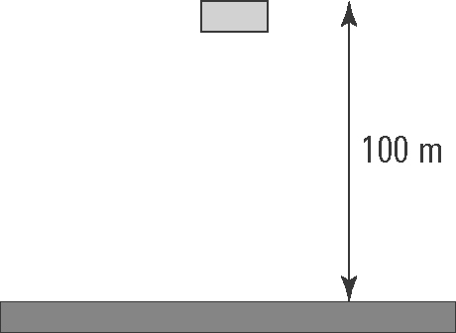
At any point during the fall, the object has gravitational potential energy (GPE) and kinetic energy (KE) given by the formulae:
GPE = mgh and KE = mv²
where m = mass (kg), g = 9.8 m/s², h = height (m) and v = speed (m/s).
- Use these formulae to complete the following table.
h (m) | GPE (J) | v (m/s) | KE (J) | GPE + KE (J)
100 | 9800 | 0 | 0 | 9800
90 | 8820 | 14.000 | 980
80 | 7840 | 19.799 | 1960
70 |  | 24.249
60 |  | 28.000
50 |  | 31.305
40 |  | 34.293
30 |  | 37.041
20 |  |  | 7840
10 |  | 42.000
0 | 0 | 44.272
- Outline how GPE changes during the fall.

- Outline how KE changes during the fall

- Outline how the sum of GPE and KE changes during the fall.

- Convection
Consider the following illustration showing the movement of air near the ocean shore. Describe how the production of convection currents makes the climate near the coast milder than it is inland.
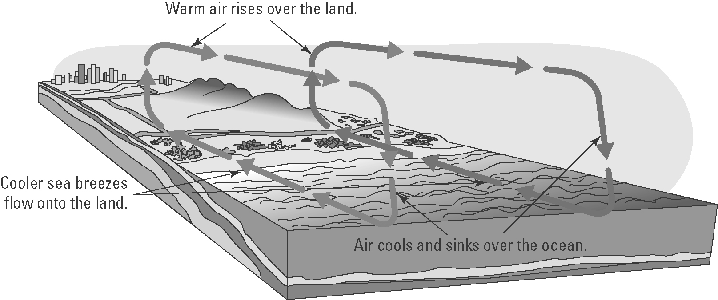

- The diagram shows an incandescent light bulb.
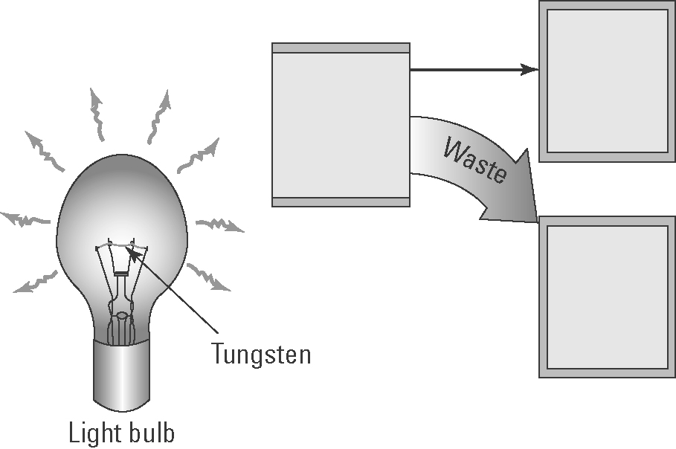
- Explain how an incandescent light bulb generates light.

- Insert the following words in the boxes in the diagram: heat energy, electrical energy, light energy
- Explain why incandescent light bulbs are not energy efficient.

- The diagram below shows the procedure a student used to measure the intensity of reflected light from various materials and compare it with light reflected by a normal mirror.
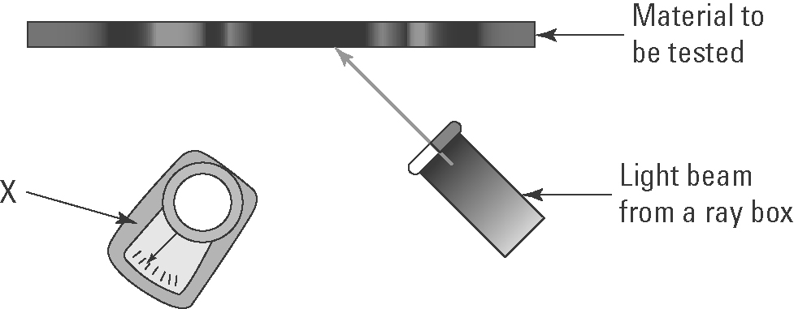
(a) Identify the measuring device X.

(b) Why is a normal mirror also tested?

(c) Identify the variables that need to be controlled.

(d) The following materials were tested: shiny white cardboard, dull black cardboard and shiny black cardboard. Predict which cards will reflect the:
(i) most light energy

(ii) least light energy.

- Wavelength and frequency
The following diagram shows two vibrating tuning forks producing sound waves.
A | 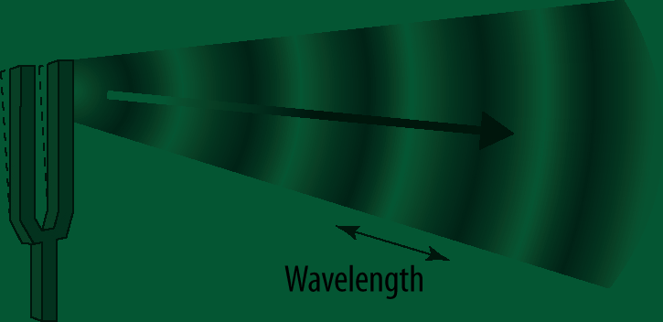 | (a) Identify the features of the wave labelled X and Y.  X:  Y:
B | 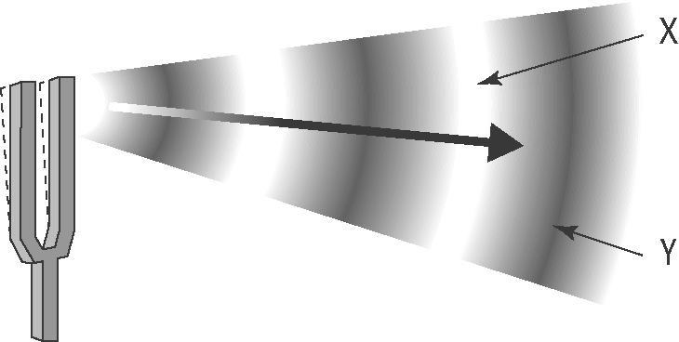 | (b) Which tuning fork produces sound waves with the lower pitch? Explain.

- Speed of sound in water
The following graph shows how the speed of sound (in m/s) in water varies with temperature (in °C).
(a) The labels and units on each axis are not shown. Insert these labels and units.
(b) Give the graph a title.

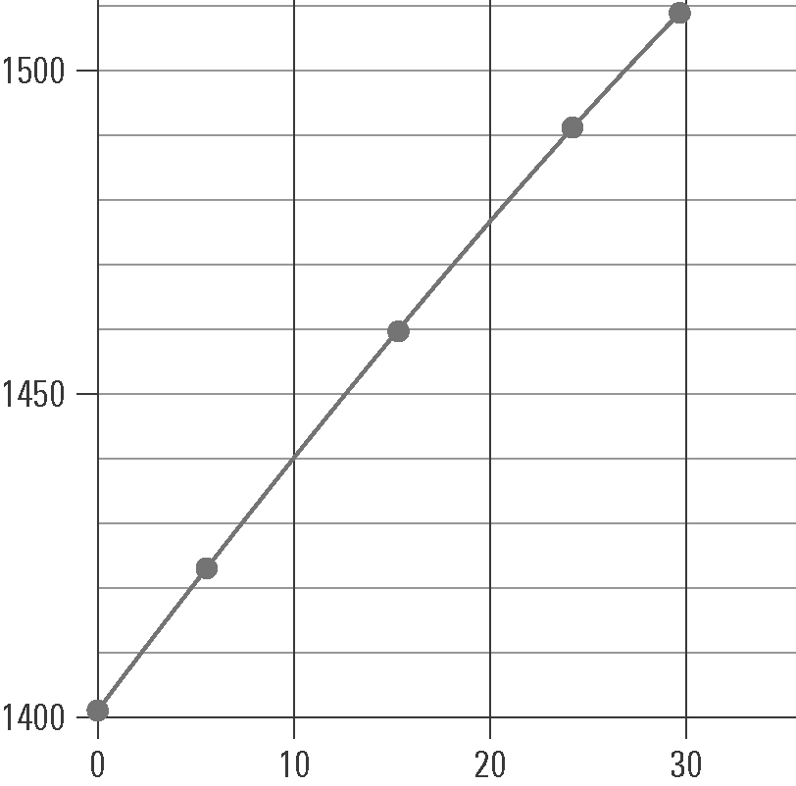

(c) Use the graph to determine the speed of sound in water at:
(i) 0 °C
(ii) 10 °C
(iii) 20 °C.

(d) In air, the speed of sound at 0 °C is 331 m/s.
(i) How many times faster does sound move in water than air at that temperature? (Hint: Divide one speed by the other.)

(ii) Explain why sound moves faster in water than in air.

